Carbamazepine
Df Sum Sq Mean Sq F value Pr(>F)
Treatment2 9 18.5 2.1 1.903 0.0686 .
Nutrients 1 493.5 493.5 457.149 <2e-16 ***
Treatment2:Nutrients 9 12.2 1.4 1.251 0.2825
Residuals 60 64.8 1.1
---

Levene's Test for Homogeneity of Variance (center = median)
Df F value Pr(>F)
group 19 1.1508 0.3287
60

Shapiro-Wilk normality test

data: resid(carb_2way)
W = 0.96252, p-value = 0.01921
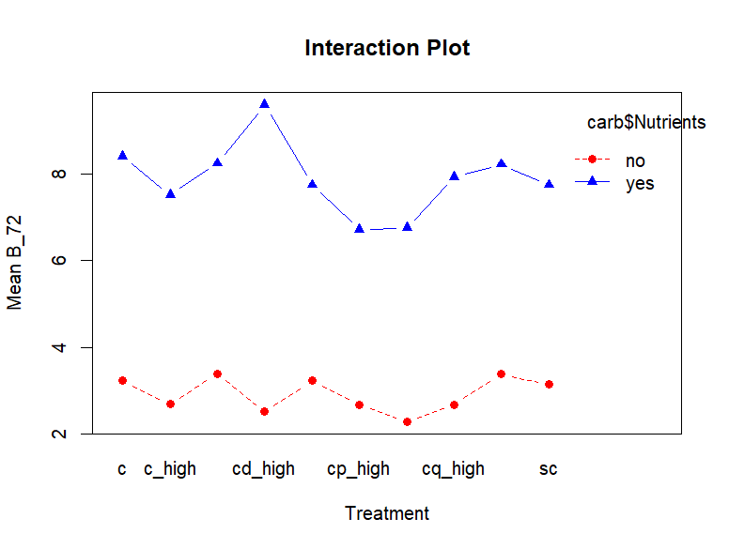
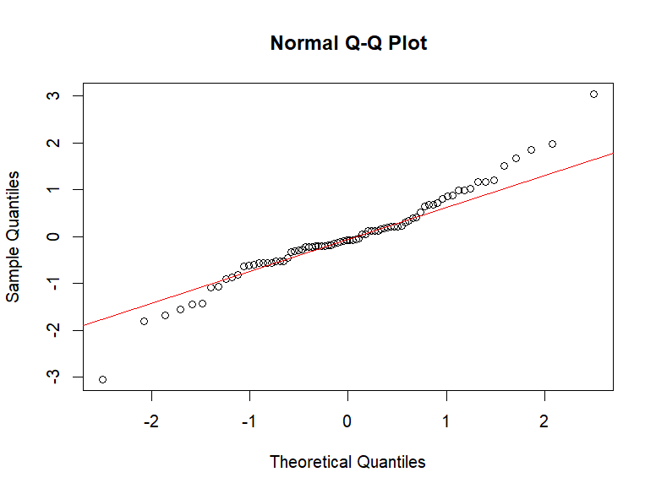

PFOS
Df Sum Sq Mean Sq F value Pr(>F)
Treatment2 9 23.84 2.65 2.960 0.005611 **
Nutrients 1 128.79 128.79 143.917 < 2e-16 ***
Treatment2:Nutrients 9 30.30 3.37 3.762 0.000839 ***
Residuals 60 53.69 0.89
---

Levene's Test for Homogeneity of Variance (center = median)

Df F value Pr(>F)
group 19 1.3815 0.1711
60

Shapiro-Wilk normality test

data: resid(pfos_2way)
W = 0.96899, p-value = 0.04893
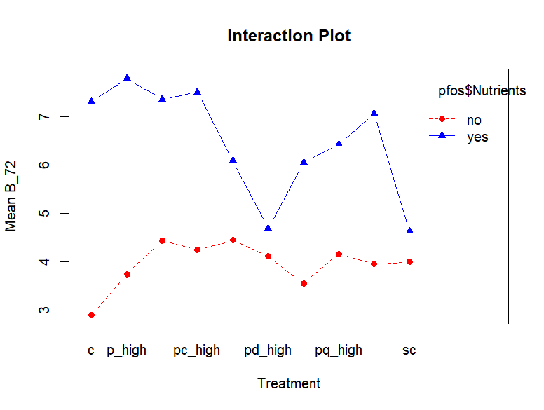
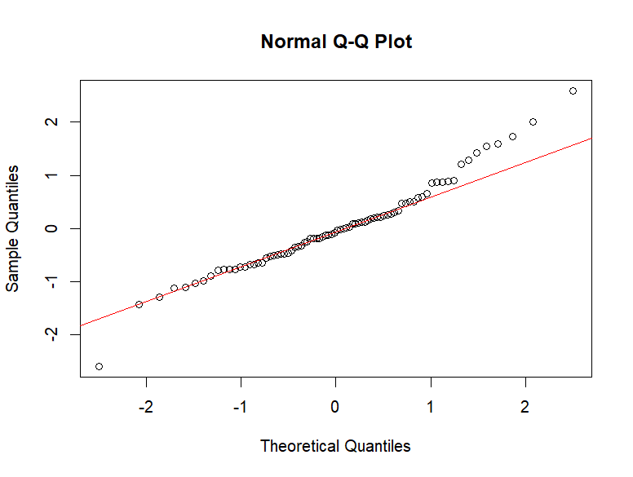

6ppd-q
Df Sum Sq Mean Sq F value Pr(>F)
Treatment2 9 134.2 14.9 5.765 9.67e-06 ***
Nutrients 1 560.0 560.0 216.485 < 2e-16 ***
Treatment2:Nutrients 9 119.1 13.2 5.117 3.89e-05 ***
Residuals 60 155.2 2.6
---

Levene's Test for Homogeneity of Variance (center = median)
Df F value Pr(>F)
group 19 2.3619 0.006092 **
60
---

Shapiro-Wilk normality test

data: resid(quin_2way)
W = 0.9011, p-value = 1.356e-05
